It all started with that bloody mug.
It was quite valuable and unusual, even for an artifact.
It took days to secure the caverns enough for the extraction of the beast's body to take place. Just as plans and negotiations were under way on what to do with all of the bones and leather that was left by the beast, this joker runs in, grabs everything and runs with it.
The moment she procured the bones she was sentenced to death, with the execution postponed til she was done with whatever she was making.
No idea if it was her plan all along, or if Ber just got lucky, but by claiming the mug as a family heirloom she saved her life. By a twist of fate she was distantly related to Mafol. This meant that anyone who spoke against the family heirloom would also speak against Mafol, which no one dared to do. Thus Ber's execution was postponed indefinitely. And the mug was put on display in the tavern for all to see and admire. And admired they did:
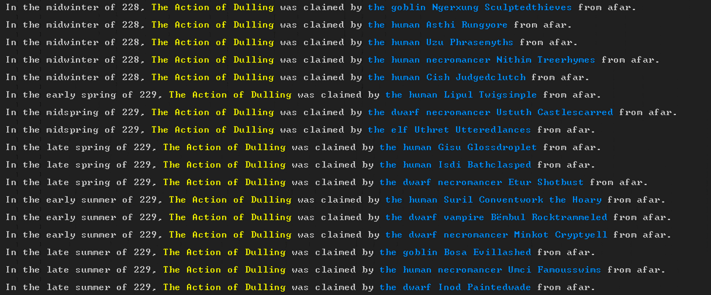
over the coming months many greedy eyes looked at the mug with envy. Talks of outsiders boasting how they will one day claim it have run so rampant that even Mafol could not ignore them. And once she was chosen as the Baroness she decided to move the Action of Dulling to her own personal dinning room.
But alas, it was a cruel twist of fate that followed her decision. For she moved the mug out of fear that someone might steal it – yet moving it to a remote location away from public sight was exactly the opportunity some plotting scoundrels were waiting for.
Under the premise of showing his respect to the newly nominated Baroness, the human Necromancer Iyathi carried out the heist of the century.
He grabbed the goods and ran, and instructed Uzol what to do to delay detection.
And as soon as the thief was safely out of reach, the first Moon Ape incident occurred, throwing the fortress in to chaos for weeks.
All of this was part of a bigger plot, masterminded from the shadows by an elf.

Full details and the current location of the mug are yet to be know. The enemy base of operation is located on the other end of the continent, an average 20 days of travel both ways.
Attempts at acquiring information on the whereabouts of the mug, or the location of the culprits have been unsuccessful.
The fact that the theft of the mug was declared a state secret, and officially the mug still resides at the fort added even more complexity to the matter, since we can't send out knights in quest of it.
Where The Action of Dulling once stood, now only an imitation made by Mafol in resides.

